Monthly Report (April)

Brotherhood Financials

**Take note** : We are approaching the middle of the year, just a couple of months to go. I urge you, brothers, do consider your annual budget and whether or not you will be able to continue as planned. The July contributions (the half-year period, end of July through to end of December) is planned to **increase to R1000 per month**. So, please do consider your annual budget and find out if this will be possible and communicate it with the Brotherhood Stokvel.

1. **Summary**

|  |  |
| --- | --- |
| **To-date contributions made by**  **members (total of R12,000.00**) | **Total interest earned thus far.**  **(R106.33 from date of conception)** |
| **Share value of funds by contribution** |  |

1. **Individual Contributions**

1. **Interest Rates and Changes**

In the 4 months since the initiative began, we have seen an increase in interest rates twice, once in February, and once in April.

We expect the next time the interest rates will change will be once we pass the R20 000.00 mark on our contributions.

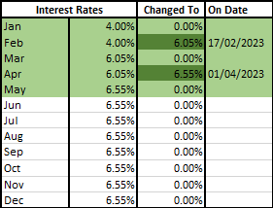

1. **Monthly int. from the 1st day of conception.**

Note the R0.01 difference between the calculated interest and the actual interest of the 2nd Mnth (3rd row). After investigating, I realized that the number of decimal places that FNB rounds off to is not very clear. Whether they round off to 1, 2, 3 or 4 decimals, or whether they round up or down to whole numbers, is not very clear. To the best of my knowledge, I have realized it works out more accurately towards the end of the month prior to making the new round of contributions.

Nonetheless, the amounts are matched up to the bank’s amounts as seen in the 4th row (3rd Mnth’s Calc. Int.)

1. **Late and Unpaid Contributions**

Members behind on payments and late on due dates as per BBS agreements initialised upon conception of the stokvel.

*Note that deadline for any and all payments is on the first day of the each month, after which there may be a penalty as discussed in previous meetings and gatherings.

Members take heed to give fair notice as discussed in previous gatherings to avoid such consequences.

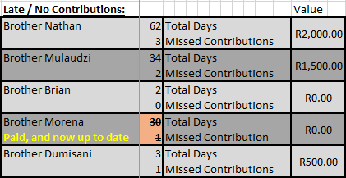

1. **Planned vs Progress**

Please see below for a clear overview of the planned budget vs our current progress.

As it stands, we are R4000 behind on contributions or R4 096.36 (R16 202.69 – R12 106.33) if we consider the projected interest.

**PLEASE NOTE:** The reason the Projected Budget table ends on the month of April and that of the Actual Progress ends on the month of May is because some contributions for April were made in May (about 3 or so days after the month of April, as you will see in the Excel sheet or under “Individual Contributions” in the first page of this report).

**Planned Budget**

**Actual Progress**

